

**COASTAL CAFÉ LUNCH MENU**

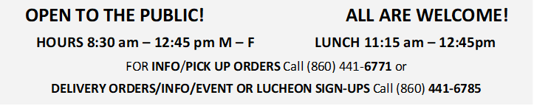

DECEMBER 2022

|  |  |  |  |  |  |
| --- | --- | --- | --- | --- | --- |
| **MONDAY** | TUESDAY | WEDNESDAY | THURSDAY | FRIDAY | SATURDAY |
|  |  |  | 1  MEAT LASAGNA | 2  PARMESAN TALAPIA | 3 |
| 5  CHIPPY CHICKEN | 6  BBQ CHICKEN LEGS | 7  TERIYAKI BEEF & PEPPERS | 8  MEATBALL SANDWICH | 9  CRAB CAKES | 10 |
| 12  SALISBURY STEAK | 13  SPAGHETTI & MEAT SAUCE | 14  BAKED HAM | 15  MANICOTTI | 16  HOLIDAY LUNCHEON | 17 |
| 19  MEAT LOAF | 20  VEGETABLE LASAGNA | 21  LIVER & ONIONS | 22  BAKED CHICKEN THIGHS | 23  BAKED SALMON | 24 |
| 26  CLOSED | 27  STUFFED CABBAGE | 28  CHICKEN STIR FRY | 29  PORK CHOP | 30  MANGO TALAPIA | 31 |

